**FINALPROJECTDOCUMENTATION**

**PROJECT IDEA**

**CURRENCY CONVERTER APPLICATION**

**GitHub Link:** [https://github.com/mammar003/banoabil_python_course](https://github.com/mammar003/banoabil_python_course%20)

**URL of install library:** <https://pypi.org/project/CurrencyConverter/>

* **TEAM MEMBERS:**

1. **MUHAMMAD TUHEED AHMED**
2. **MUHAMMAD MAAZ**
3. **MUHAMMAD HAMMAD**

* **PURPOSE:**

The purpose of this project is to create a user-friendly currency converter application with a Graphical User Interface (GUI) using Python. The application allows users to convert currencies between different countries based on the latest exchange rates fetched from a website. This currency converter is particularly useful for individuals or businesses that need to frequently convert currencies for financial transactions or planning purposes.

* **FUNCTIONALITY:**

**GUI Interface:** The application provides a simple and intuitive interface using Tkinter, a standard GUI toolkit for Python.

**Currency Selection:** Users can select the currency they want to convert from and to using dropdown menus.

**Amount Input:** Users can input the amount they wish to convert.

**Conversion:** Upon clicking the "Convert" button, the application fetches the latest exchange rates from a website, performs the currency conversion, and displays the converted amount.

**Error Handling:** The application handles various errors gracefully, such as invalid input or failure to fetch exchange rates.

* **Usage Instructions:**

**Launch the Application:** Run the Python script containing the currency converter code.

**Interface:** The application window will appear with the following elements:

* Dropdown menus to select the currency to convert from and to.
* An entry field to input the amount.
* A "Convert" button to initiate the conversion process.

**Select Currencies:** Use the dropdown menus to select the currencies you want to convert from and to. The default currencies are USD and EUR.

**Input Amount:** Enter the amount you wish to convert into the entry field.

**Perform Conversion:** Click the "Convert" button to perform the currency conversion.

**View Result:** The converted amount will be displayed in a popup window.

**Error Handling:** If there are any errors, such as invalid input or failure to fetch exchange rates, error messages will be displayed to alert the user.

* **Supported Currencies:**
* United State Dollar (USD)
* Euro (EUR)
* Indian Rupee (INR)
* United Kingdom (GBP)
* Newzeland Dollar (NZD)
* Australian Dollar (AUD)
* Japanese Yen (JPY)
* Canadian Dollar (CAD)
* Brazil (BRL)
* Chinese Yuan (CNY)
* Bulgaria (BGN)
* Czech Republic (CZK)
* Denmark (DKK)
* Hong Kong Dollar (HKD)
* Hungary (HUF)
* Iceland (ISK)
* Indonesia (IDR)
* Korea (KRW)
* Switzerland (CHF)
* Malaysia (MYR)
* Mexico (MXN)
* **Notes:**
* Ensure that your computer has an active internet connection to fetch the latest exchange rates from the website.
* The application currently supports conversion between USD, EUR, and GBP. You can modify the code to include additional currencies if needed.
* Feel free to customize the GUI or add additional features to suit your requirements.

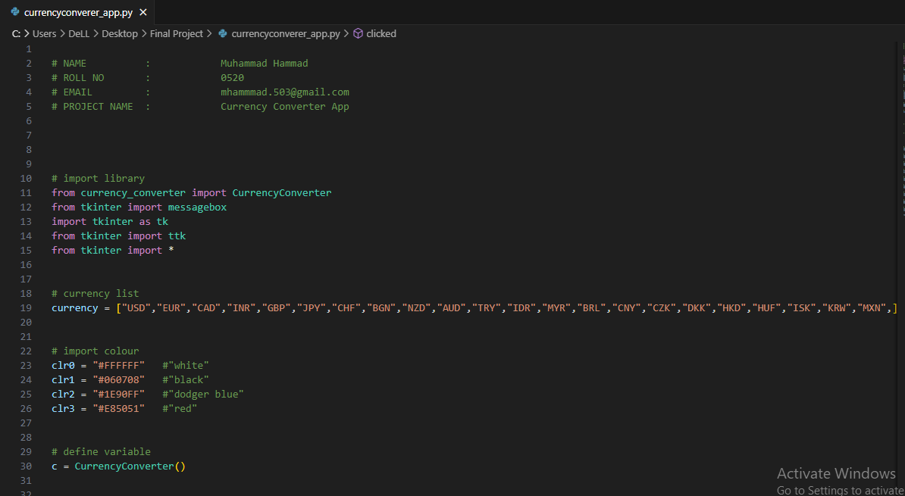

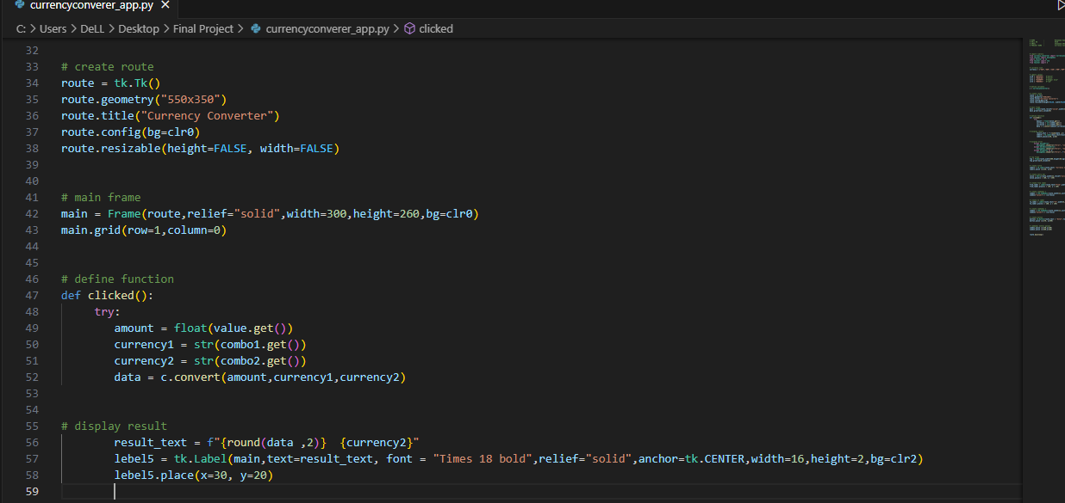

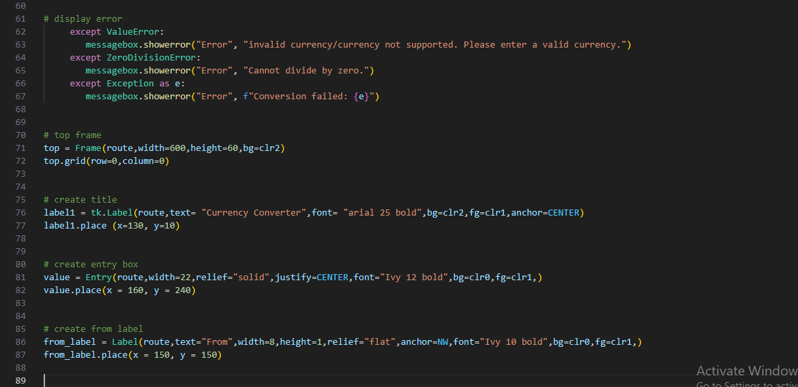

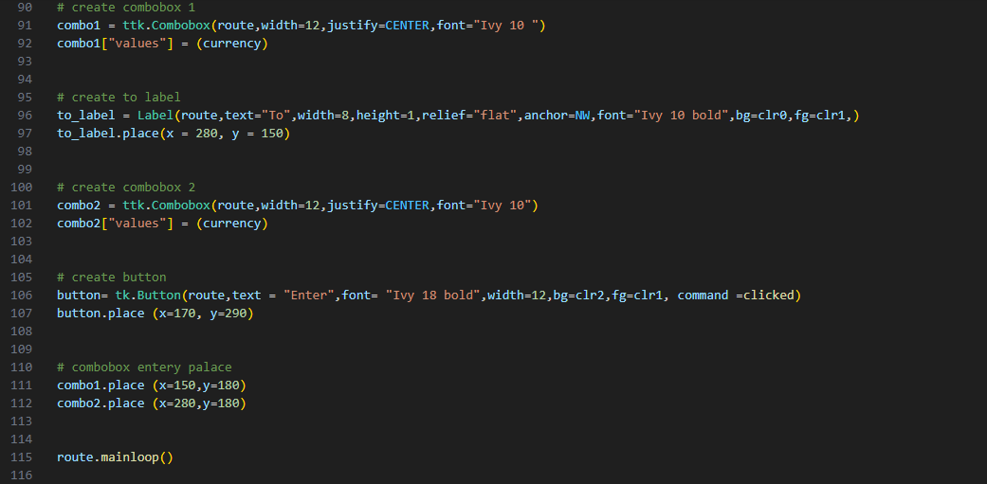

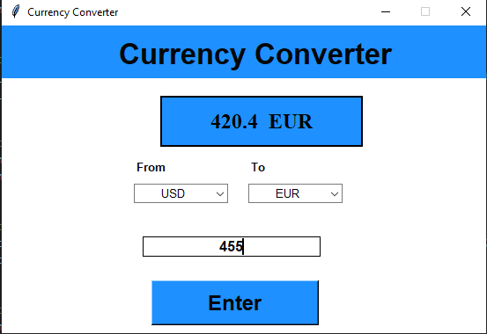

**“THE END”**